 | Registration Form | 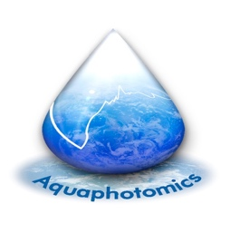
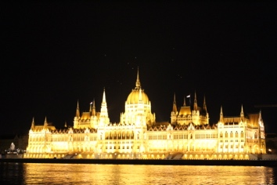 | THE SECOND AQUAPHOTOMICS  EUROPEAN CONFERENCE  LURDY INTERNATIONAL CONFERENCE CENTER Budapest, Könyves Kálmán krt. 12-14., 1097

How to register

- Please complete this registration form (one per participants) and send it to us via email: aquaphotomics.eu@gmail.com.

- Our staff will contact you within a few business days. You will receive a PDF file of the confirmed registration form with your confirmation number and the total payment amount via e-mail.

- You will need to put your full name and the confirmation number on the wire transfer form when making payment (Ex.: “Stephen Smith 0001”).

- Advance Registrations must be received no later than 31st October 2019. If you encounter any problems registering, please email to aquaphotomics.eu@gmail.com.

1. Participants information

Title: Mr. Ms. Mrs. Miss Prof. Dr. other:_________________________

Family name: __________________________________________________________________
Other name: ___________________________________________________________________
Affiliation: ____________________________________________________________________
Address: _________________________________ _____________________________________
Postal/Zip code: ________________________ City: ____________________________________
Country: ______________________________________________________________________
Telephone: ___________________________ E-mail: ___________________________________

Please note that the name and title you give here will be printed on your badge and the participants’ list.

2. Details of program participation

Day 1 – Workshop and tour of Budapest (3rd December)
I am interested in attending the free workshop
I am interested in going for the conference tour at an extra cost of 90 Euro*
*This cost is not included in the conference fee and covers meals (lunch and dinner) and entrance to tourist sites (Check the second circular for more details)

Day 2 – Conference: fees (4rd December)
Conference fees include admission to conference sessions, workshop, tea/coffee, lunch, registration, conference materials and dinner.
 | Early bird | Normal rates
Regular Conference Fee | 120 Euro | 150 Euro
Student Conference Fee** | 100 Euro | 120 Euro
** Please include a copy of your valid student card/other formal identification.

4. Accommodation
The options below are the official accommodations for the Conference:
Hotel Leonardo ****
Single room: 69 EUR/room/night including breakfast
Double room 79 EUR/room/night including breakfast
If you want to upgrade your room, you can do it at an extra cost:
Superior room for extra 10 EUR /room/night
Suite room for extra 30 EUR/room/night
Location: 10 minutes from the conference venue via tram 51.
Kindly refer to “Scientific Meeting Physics Department” making your booking with the form provided.

Hotel Actor ****
Single room (one bed): 64 EUR/room/night including breakfast
Double room (two beds) 70 EUR/room/night including breakfast
Superior Category:
Single room (one bed): 75 EUR/room/night including breakfast
Double room (two beds) 80 EUR/room/night including breakfast
Location: 10 minutes from the conference venue via tram 51.
Kindly refer to “SZIECONF” making your booking with the form provided.

Hotel Rila ** - hostel style
Single room (one bed) – 9000 HUF (27 EUR)/room/ night including breakfast
Double room – 12000 HUF (36 EUR)/room/night including breakfast
Location: 5 minutes’ walk from the conference venue.
Kindly refer to “SZIECONF” making your booking on the hotel’s website http://www.hotelrila.com/

Please note! You are to book your own room through the provided forms/respective websites of the hotels. Kindly check the conference website for more information about booking a room.
Date: _________/________/_________
Conference website: https://www.aquaphotomics.com/european-chapter/
Contact email: aquaphotomics.eu@gmail.com

