The 4th Aquaphotomics International Conference
Exploring Water Molecular Systems in Nature

(March 20 - 22, 2021, Kobe, Japan)

Registration Form

For registration, please complete and email this form to conference@aquaphotomics.com. You will receive a confirmation email with your confirmation number in a few business days. When you receive the confirmation email, please proceed with payment.

Confirmation number: | OFFICIAL USE ONLY
Accepted on: | OFFICIAL USE ONLY
Total Fees: | OFFICIAL USE ONLY

Please mark the appropriate box as “☒”.
☐ Student |  | (Early bird*: 10,000 JPY / Full: 15,000 JPY)
☐ Academic |  | (Early bird*: 20,000 JPY / Full: 25,000 JPY)
☐ Regular |  | (Early bird*: 23,000 JPY / Full: 28,000 JPY)
☐ March 20 Only** |  | 10,000 JPY
Title (Ms./Mr./Dr./Prof.):
First name:
Middle name:
Last name:
Affiliation:
Mailing address:
Country:
Tel:
Fax:
E-mail:
Attendance: | ☐ In-person ☐ Online (Zoom) ☐ Undecided

Information

Registration Fee
 | Early Bird Discount* | Full
Student | 10,000 JPY | 15,000 JPY
Academic | 20,000 JPY | 25,000 JPY
Regular | 23,000 JPY | 28,000 JPY
March 20 only** | 10,000 JPY
*Please make payment before January 22 (Fri), 2021 for Early Bird Discount.
** This option covers access to the conference on March 20 only (Excluding access to March 21-22). English and Japanese real-time interpretation is provided on March 20 only.

Cancellation Policy for Registration fee
- Cancel before or on February 19 (Fri): Full refund
- Cancel after February 19 (Fri): Non-refundable

-------------------------------------------------------------------------------------------------------
We look forward to welcoming you all at the conference.
Please feel free to contact us if you have any questions or comments.

With best regards,
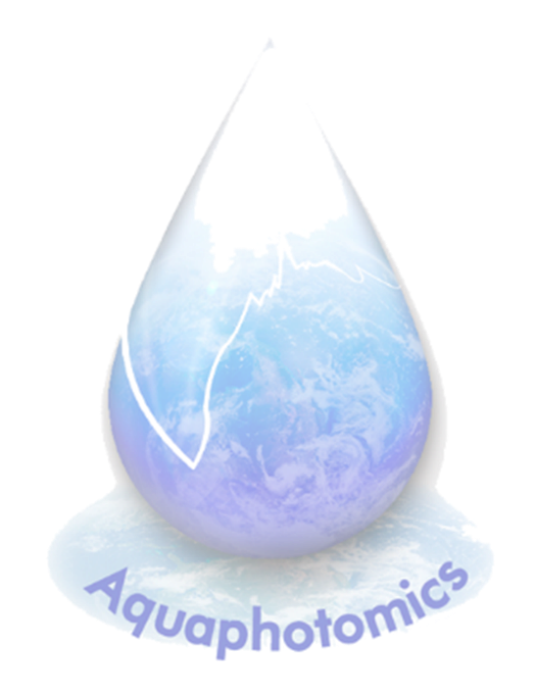
Professor Roumiana Tsenkova
Chairperson, the 4th Aquaphotomics International Conference Organizing Committee

